API Testing with Robot Framework

Step 1: Install Library

- Open command prompt (cmd)
- Type those two libraries:

pip install robotframework-requests
pip install robotframework-jsonlibrary

Step 2: Setup Setting on Robot Framework Script

- Open Python IDE or Robot Framework IDE (RIDE)
- Create new test suite
- Under ‘Setting’ section, set three libraries
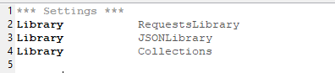

Step 3: Creating Test Case

For this documentation, https://reqres.in/ is based URL for API testing.

- Firstly, create new test case by typing test case name under ‘Test Case Section’
- Type script as figure below for connecting to base URL:
${get_respond}= get on session API_testing url=/api/users/2
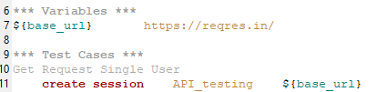

- The first is the keyword from library that. The second is the name of session which we give any name. Third is the based API URL that we want to test.

- Or you can type those script on Test Setup under Setting as shown below:
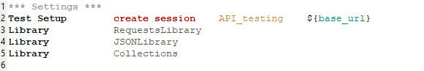

Note: Test Setup is the keywords/step that be run before test cases inside test suit be executed.

- There are 4 test cases or requests that common be used in API testing: GET, POST, PUT, DELETE

Step 3.1: GET request test cases

- GET request is a keyword that get information/data from API
- ${get_respond}= get on session API_testing url=/api/users/2
log to console ${get_respond.status_code}
log to console ${get_respond.content}
log to console ${get_respond.headers}

Step 3.2: POST request test case

- POST request is a keyword that add/upload information/data to API

${body2}= create dictionary name=morpheus job=leader
${header2}= create dictionary Content-Type=application/json

${post_response2}= Post Request API_testing url=/api/users data=${body2} headers=${header2}

Step 3.3: PUT request test case

- PUT request is a keyword that update existing information/data in API.

${body3}= create dictionary name=morpheus job=leaderExecutive
${header3}= create dictionary Content-Type=application/json
${put_response3}= Put request API_testing /api/users/2 data=${body3} headers=${header3}

Step 3.4: DELETE request test case

- DELETE request is a keyword that delete information/data from API.
- ${delete_response4}= delete request API_testing url=/api/users/2

Step 4: Status Code and Validation

- Status:
log to console ${get_respond.status_code}
${status_code} convert to string ${get_respond.status_code}
should be equal ${status_code} 200

